Budmerice and Bazovica
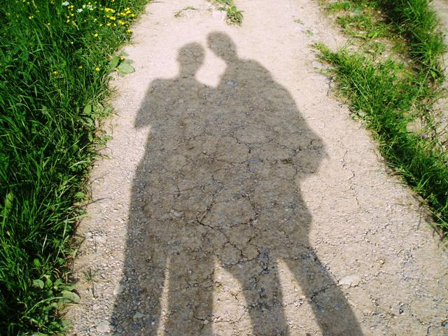
On my second day in Slovakia we went on an all day, 40 kilometer bike trip from Trnava to Budmerice which is right at the foothills of the Male Karpaty. This photo is from a field at the beginning of the ride, and you can see the mountains we were biking to in the distance.
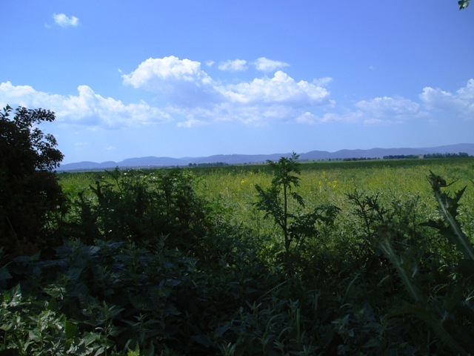
One of the first things I noticed on our ride was how lushly green and exploding with vegetation all of Slovakia seemed to be this spring. And on our way to the red and orange roofed villages of Bielykostol, Cifer, Jablonec and Budmerice we passed many fields of peas, corn, wheat and the yellow-flowering repka olejna which is used for cooking oil, but what really caught my eye was the wild flowers and scrub brush where I was surprised to find whole fields of poppies, specifically vlci mak (the wolf poppy), a beautiful and in some countries illegal wild flower.
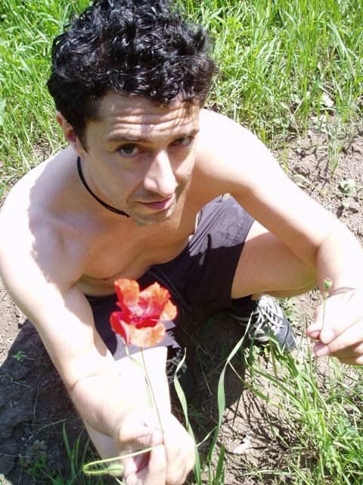
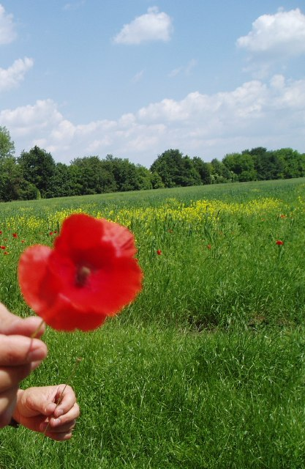
I was also surprised to find that durman—one of the fiercest hallucinogens on the planet—grows freely along the roadsides with other thorny weeds like bodliak (and for what it's worth, the tropane alkaloids of durman can produce hallucinations indistinguishable from reality, and while that may sound interesting enough, modern usage is littered with horror stories the likes of unsuspecting kids looking to get a cheap high drowning in six inches of water believing they were fish, so this is definitely NOT a plant to mess around with ! )
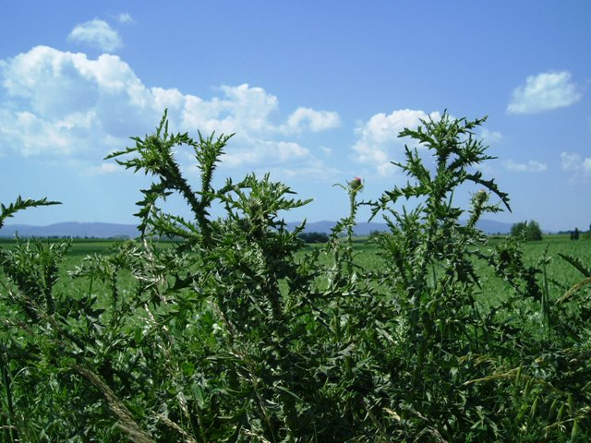
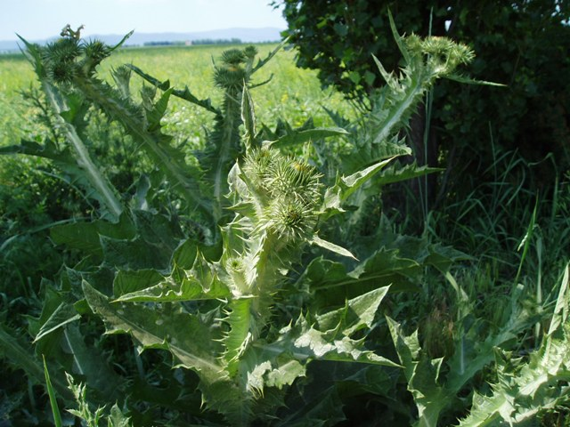
One of the other plants we found along the way was baza, a flowering bush which we gathered bunches of flowers from to make bazovica, a kind homemade carbonated lemonade. This bazovica recipe was passed to Lubka from her lifelong neighbor and surrogate aunt, “Don Tetushka” who also helps here when it’s time to separate edible herbs and mushroom from their inedible and dangerous cousins:
boil 5 or 6 liters of water with 400 grams of sugar
add 2 sliced lemons and 3 flowers of baza
cool to 40 degrees centigrade and add a pinch or two of yeast about the size of a pea
let it sit for 12 hours then strain it into bottles and refrigerate for 1 to 3 days
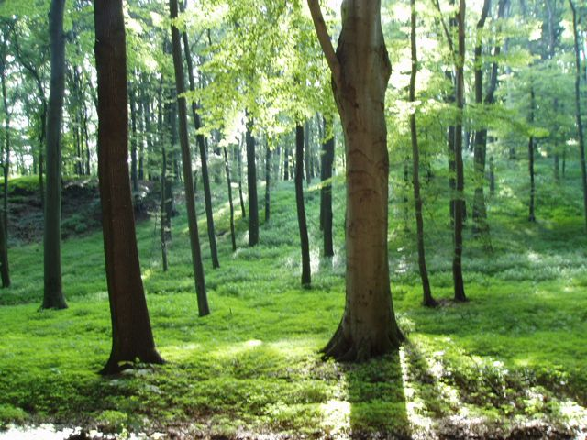
As it turned out we never did hike in Budmerice that day…the shadows were getting long and today we had the special feeling of open fields and biking in our blood. So we ate a pile of fresh peas, took a nap and pedaled back to Trnava to relax and save the woods and the mountains for another day .
